 | Student Name _______________________  Eastern Goldfields College  Unit 3 Essential Mathematics 2016  Mental Skills Test 3
 | Time: 10 minutes Total Marks: 50 marks
CALCULATORS NOT ALLOWED
1. What is the dependent variable ?  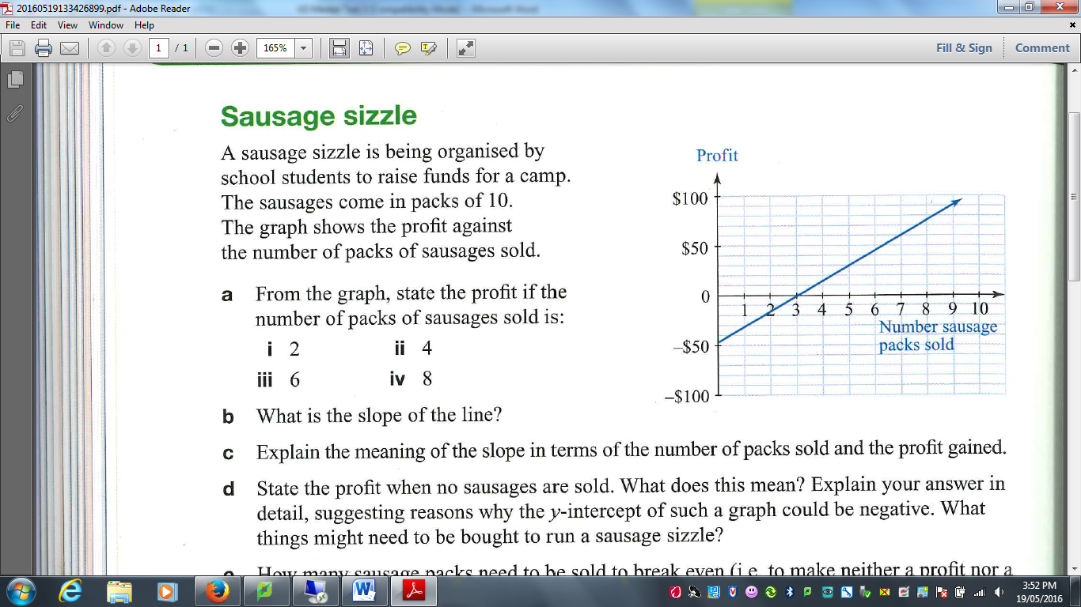 | 9. Draw a trend line on this data plot.  100%  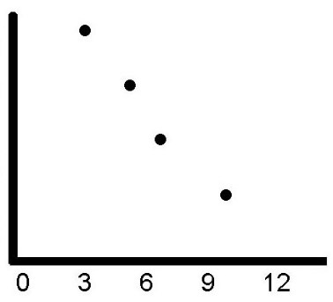  0%  Overall Grade  ^{Hours spent watching TV}
2. Is the gradient of the line positive or negative? | 10. Is the relationship in Question 9 positive or negative?
3. What is the gradient of the line? | 11. Is the relationship in Question 9 strong or weak?
4. Estimate the y intercept | 12. Describe the trend in Q9 ?
5. How many sausage packs need to be sold to  ‘break even’? | 13. Does watching TV cause the overall grade to decrease?
6. How often is the Australian Census held? | 14. Which method of sampling results in less bias, Random Sampling or Self-Selective Sampling?
7.  3m³ = _________L | 15. Write the scale 1cm represents 3km as a ratio.  1 : _______________
8. Name one type of sampling method.

